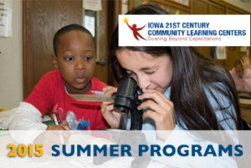
21CCLC Middle School Summer Programs

FREE for any student entering grades 6th through 8th, at any middle school location listed below.

Dates: June 7th - July 18th, Monday - Friday

Locations:
Weeks
Goodrell
Harding
Hoyt
Callanan
Meredith
Hiatt / Boys and Girls Club
McCombs /Boys and Girls Club

Brody (Separate registration, available to incoming Brody students ONLY, contact Brody 21CCLC Coordinator for details)

Two registration options for students:
- Full day (8:30-3:30)
- Morning only (8:30-12:30)
Any students entering grades 6th through 8th are invited to attend, at any middle school location. Programming is FREE for all.

McCombs and Hiatt students must register online for 21CCLC and also complete the Boys and Girls Club registration (which will be emailed upon receipt) and mailed, faxed or presented to BGC at the school site.
This grant, along with generous contributions from United Way of Central Iowa, will serve over 1000 students each summer in arts, culture, STEM, intramural sports and service learning programs. Limited transportation is available on a first come first serve basis.

Registration is ONLINE...
Register online at http://www.21cclcdm.com “Summer Programs”

Questions? Contact Heidi Brown, District Coordinator via email at heidi.brown@dmschools.org

